Lecture
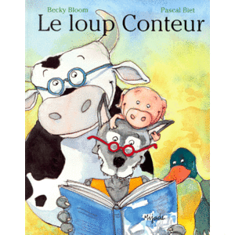
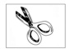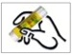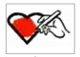
Découpe les lettres et colle-les à la bonne place pour écrire les mots. Colorie les dessins.
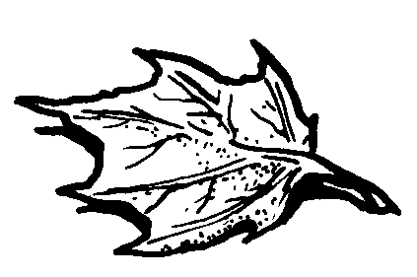 feuille
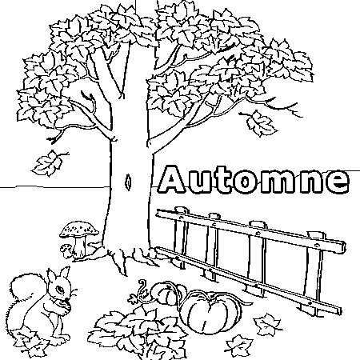 automne

---------------------------------------------------------------------------------------------------
u | o | l | u | e | n | v | f | é
m | i | t | l | a | d | e | j | e

Lecture
Découpe les lettres et colle-les à la bonne place pour écrire les mots. Colorie les dessins.
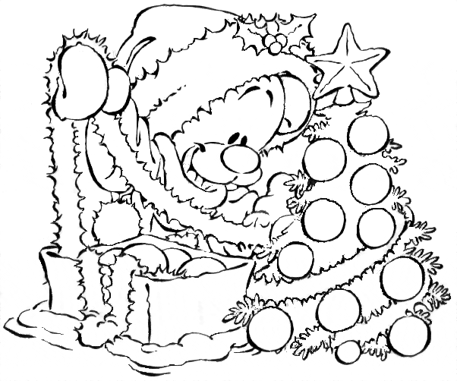 noël
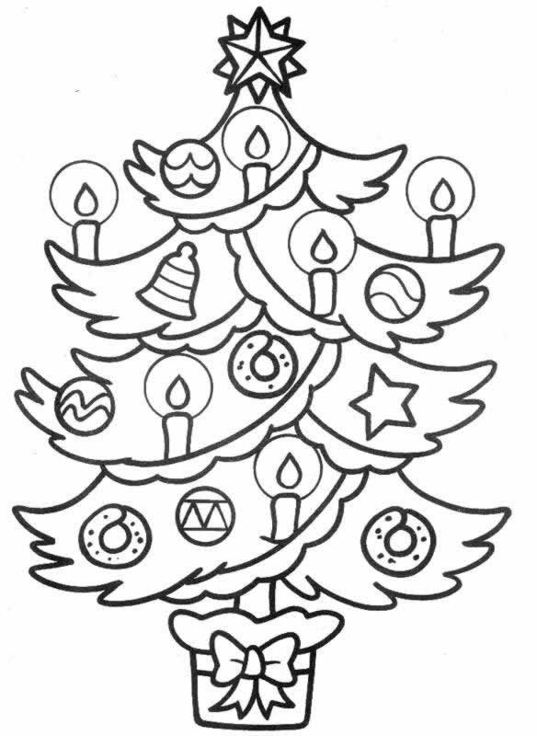 sapin

---------------------------------------------------------------------------------------------------
ë | f | j | s | u | o | q | n | a
t | i | n | e | d | p | c | l | m

Lecture
Découpe les lettres et colle-les à la bonne place pour écrire les mots. Colorie les dessins.
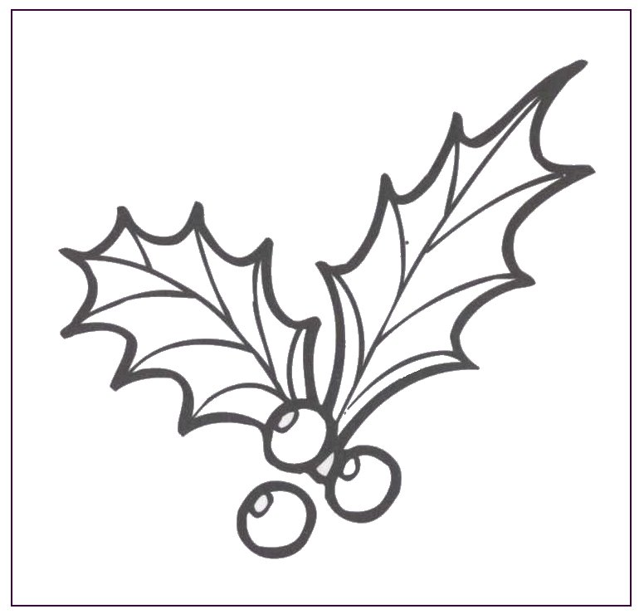 houx
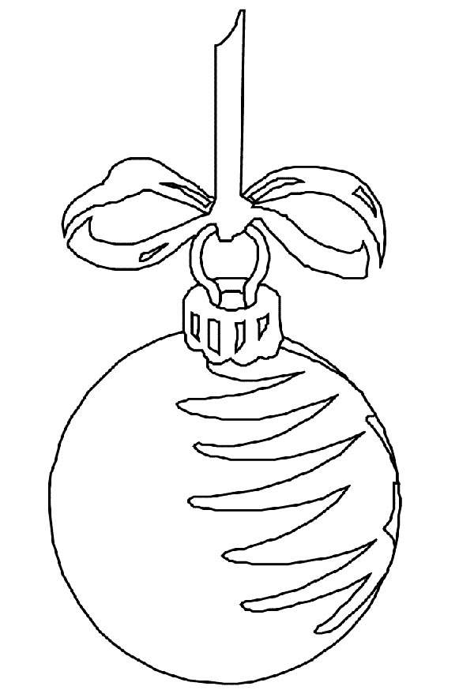 boule

---------------------------------------------------------------------------------------------------
l | r | o | h | w | t | y | e | o
a | x | z | u | k | b | s | u | v

Lecture
Découpe les lettres et colle-les à la bonne place pour écrire les mots. Colorie les dessins.
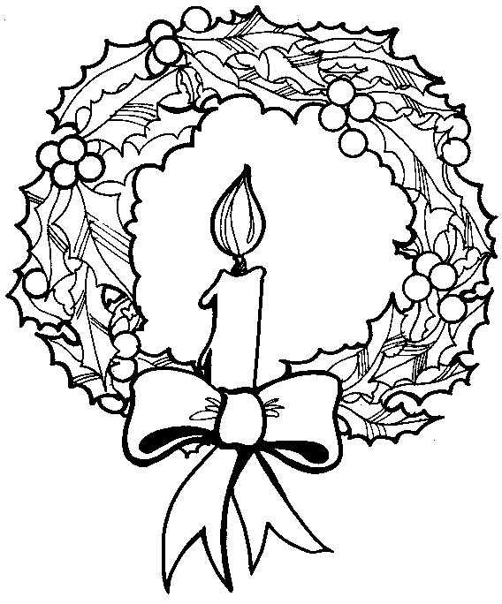 couronne
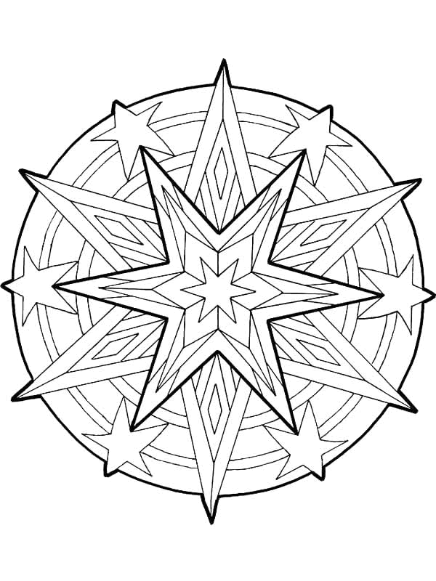 étoile

---------------------------------------------------------------------------------------------------
c | e | r | d | i | o | e | t | o
f | n | l | é | u | a | o | n | m

Lecture
Découpe les lettres et colle-les à la bonne place pour écrire les mots. Colorie les dessins.
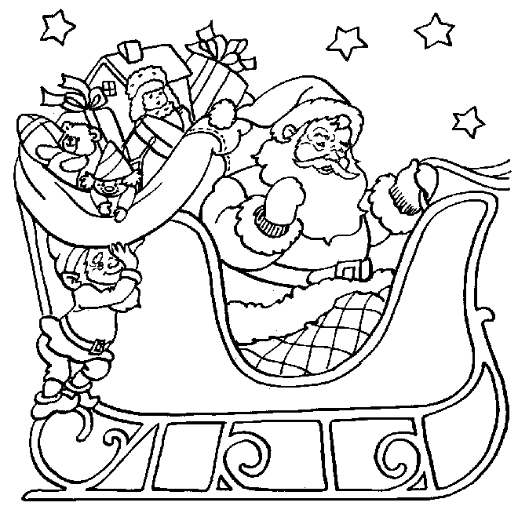 traineau
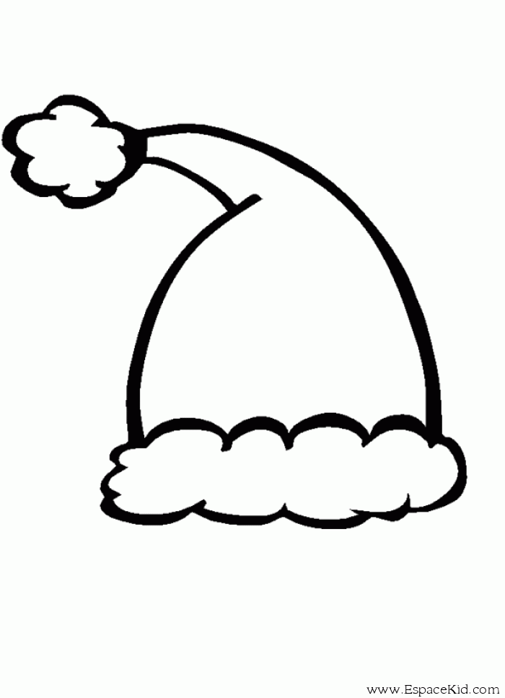 bonnet

---------------------------------------------------------------------------------------------------
l | n | n | t | a | a | b | e | m
f | t | e | r | i | u | o | n | k

Lecture
Découpe les lettres et colle-les à la bonne place pour écrire les mots. Colorie les dessins.
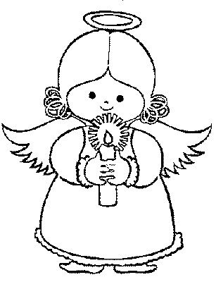 ange
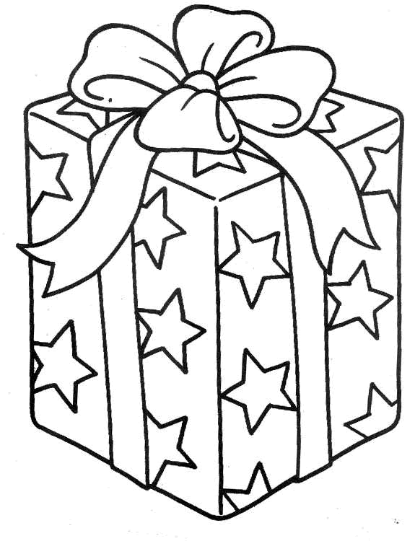 cadeau

---------------------------------------------------------------------------------------------------
g | j | e | t | a | d | u | e | o
w | a | n | m | d | c | v | l | a

Lecture
Découpe les lettres et colle-les à la bonne place pour écrire les mots. Colorie les dessins.
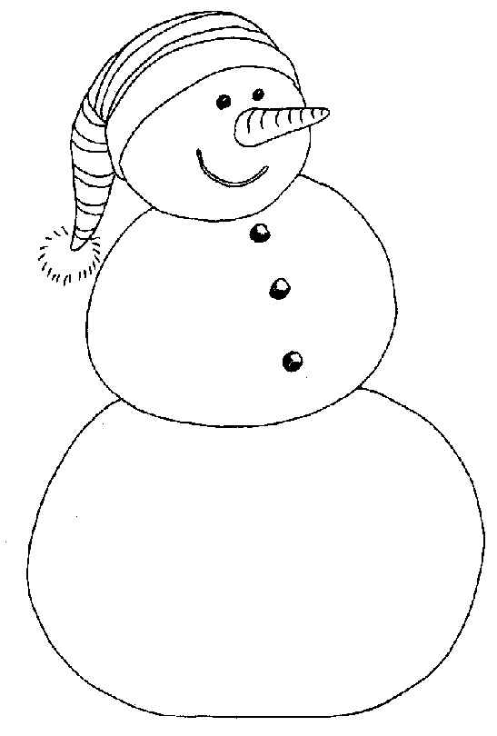 bonhomme
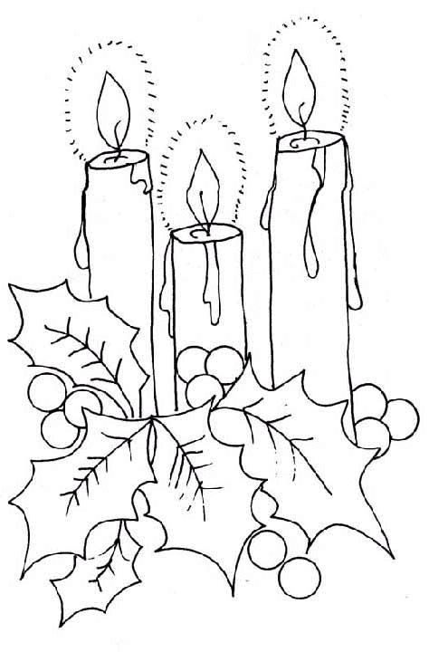 bougies

---------------------------------------------------------------------------------------------------
b | i | l | h | o | s | e | b | v
g | o | n | e | m | m | j | o | u

Lecture
Découpe les lettres et colle-les à la bonne place pour écrire les mots. Colorie les dessins.
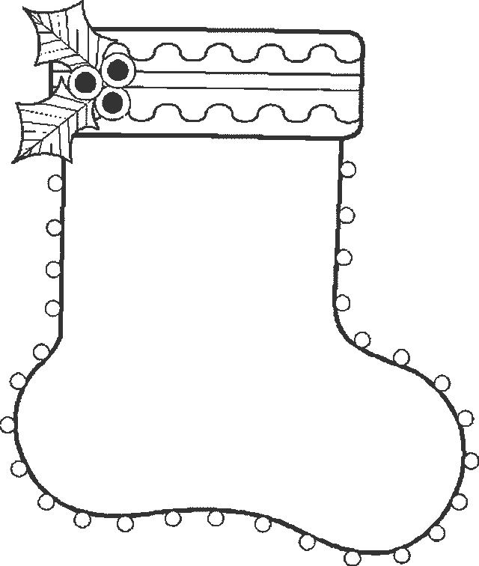 chaussette
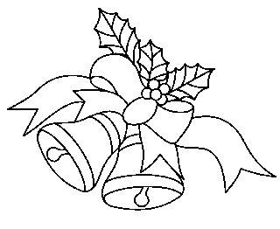 cloches

---------------------------------------------------------------------------------------------------
c | c | a | o | s | h | e | s | t
e | h | l | u | c | s | e | t | k

Lecture
Découpe les lettres et colle-les à la bonne place pour écrire les mots. Colorie les dessins.
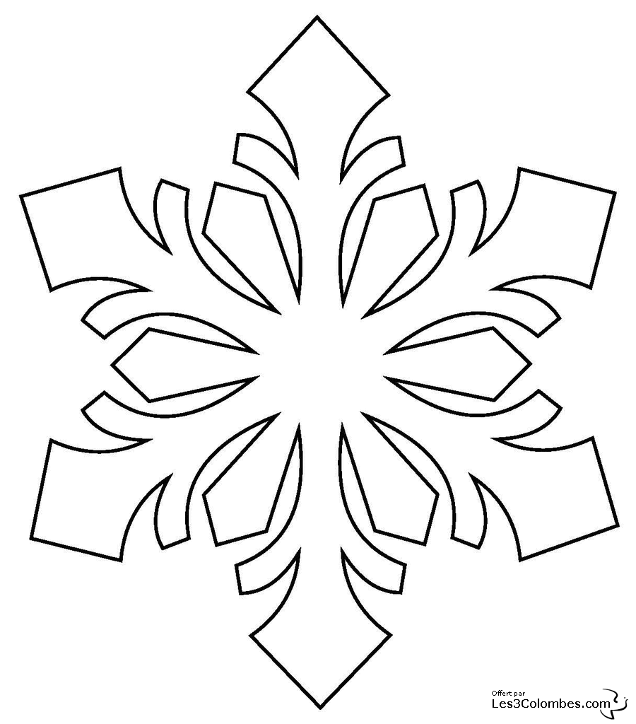 flocon
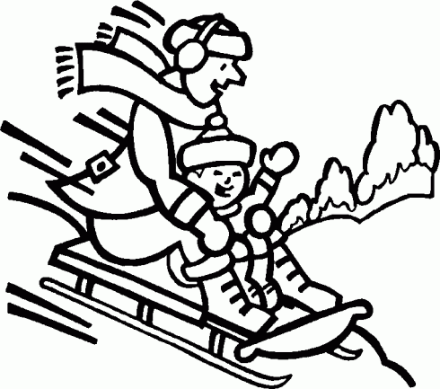 luge

---------------------------------------------------------------------------------------------------
f | h | o | a | o | m | l | v | g
e | l | k | c | d | n | j | u | w

Lecture
Découpe les lettres et colle-les à la bonne place pour écrire les mots. Colorie les dessins.
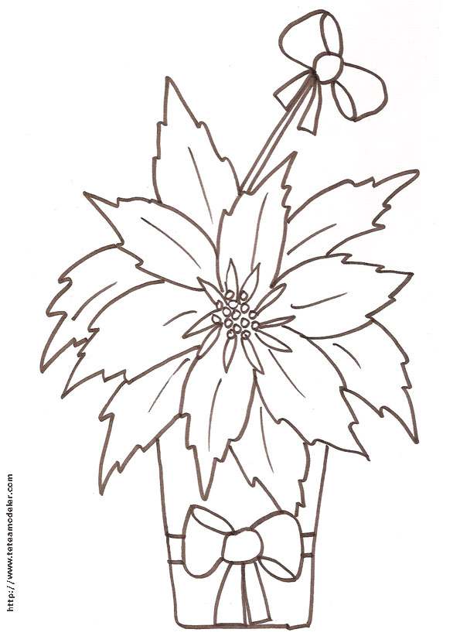 poinsettia
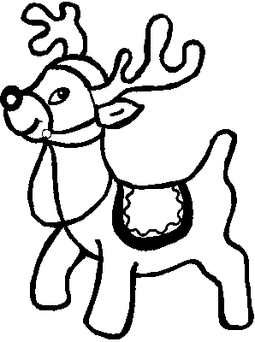 renne

---------------------------------------------------------------------------------------------------
p | r | i | n | s | e | t | m | i
a | o | e | n | n | e | j | t | o

Lecture
Découpe les lettres et colle-les à la bonne place pour écrire les mots. Colorie les dessins.

guirlande
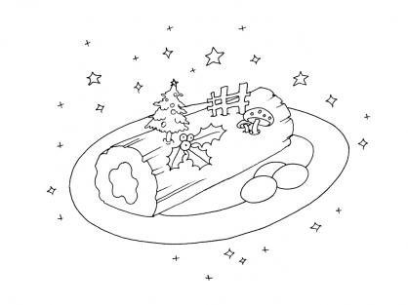 bûche

---------------------------------------------------------------------------------------------------
g | û | i | h | l | j | n | o | e
b | u | c | r | e | a | v | d | t
Lecture
Découpe les lettres et colle-les à la bonne place pour écrire les mots. Colorie les dessins.
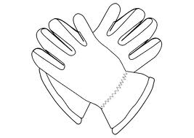 gants
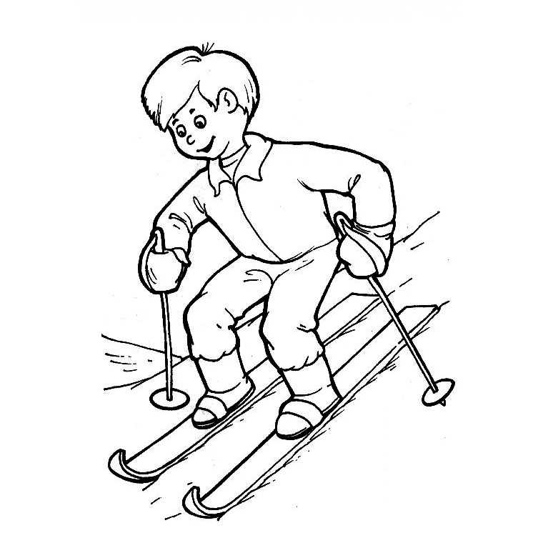 ski

---------------------------------------------------------------------------------------------------
g | m | n | l | s | u | k | w | j
o | a | d | t | b | s | v | i | x
Lecture
Découpe les lettres et colle-les à la bonne place pour écrire les mots. Colorie les dessins.
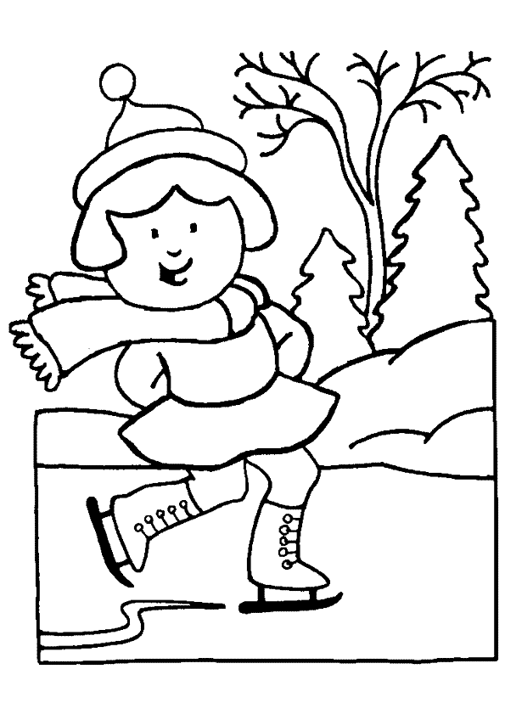 patins
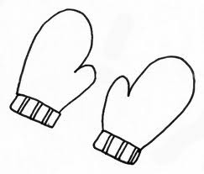 moufles

---------------------------------------------------------------------------------------------------
p | l | t | s | n | k | m | z | u
f | a | e | i | b | s | c | o | r
Lecture
Découpe les lettres et colle-les à la bonne place pour écrire les mots. Colorie les dessins.
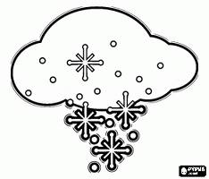 neige
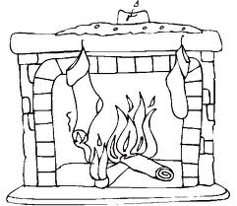 cheminée

---------------------------------------------------------------------------------------------------
n | n | i | e | e | ê | h | b | m
i | e | é | g | ë | c | o | e | k

